S1 Project Overview

# The Product

Codename S1 designates a toy quadrocopter characterized by its small size and employment of a smartphone as a remote control. The device consists of one single PCB[1] that also provides a frame for the motors and the battery. The device is shipped in a carrying case that at the same time acts as a mobile charging base. The charging base comes with its own rechargeable battery and can be charged on any USB port using the included Micro-USB cable. The estimated dimensions of the carrying case are 100x100x40mm.

All these factors should encourage the user to take the device wherever he goes.

To further enhance user experience, we consider including a replacement battery and replacement propellers in every package. We will also offer all replacement parts separately on our website.

The S1 is remote controlled via Bluetooth 4.0 Low Energy (aka Bluetooth Smart). This enables a wide range of potentially compatible devices, including iOS devices (2011 or newer), other smartphones and tablets with Bluetooth LE, Macintosh Laptops (2011 or newer) and Windows 8 Laptops. Another possibility is to build a Bluetooth dongle for a Sony PS4 controller to enable the most intuitive way of controlling the device. However, since we have very limited work forces, we fill initially focus solely on iOS devices.

# Technical Details

## Device

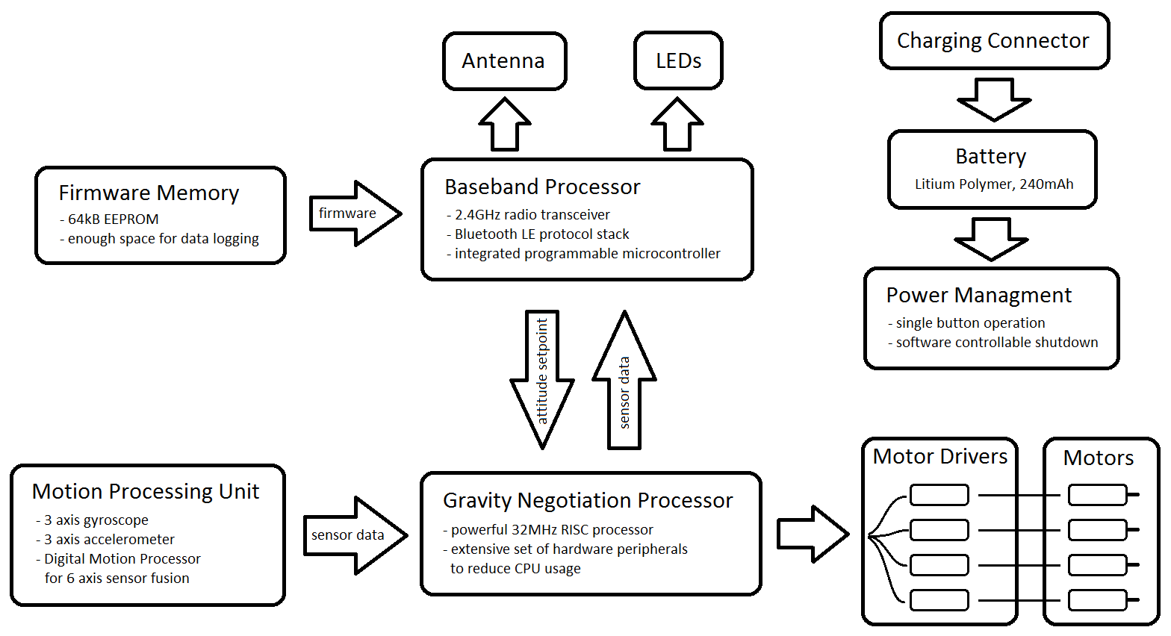

A quadrocopter is an inherently unstable flying machine and as such requires a closed high speed control loop to keep it airborne. The gravity negotiation processor makes this possible by implementing a Kalman Filter and a PID controller that maps the orientation angle to motor outputs. The Kalman Filter compensates for the lag between input and output while at the same time acting as a low pass filter. The PID controller mirrors the physical model of the quadrocopter and constantly tries to reduce the error between the measured orientation angle and the set orientation angle.

The motion processor takes away a lot of the mathematical complexity by implementing full 6 axis sensor fusion. It also provides special features such as high-G and zero-G detection that could be used to start the motors when the device is being dropped.

The baseband processor controls all communication with the remote control app on the smartphone. The chip comes with a comprehensive software framework and a wide range of sample code that will greatly simplify development.

## Base Station

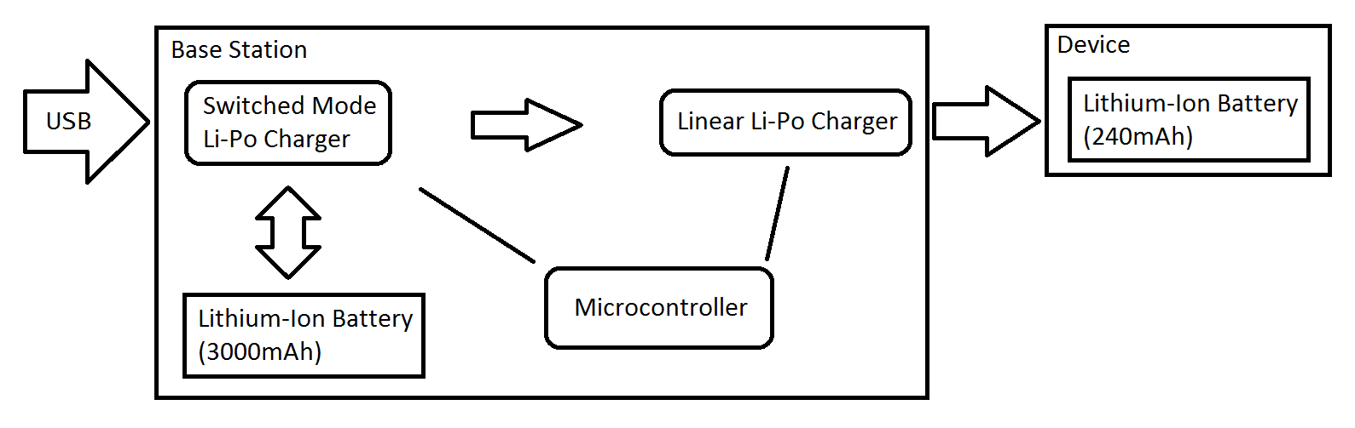

The base station battery is charged by a power management chip that is connected to the USB port. A switched mode charger is used to maximize efficiency and reduce heat dissipation. A USB interface chip requests maximum power from the USB port (500mA instead of 100mA) to accelerate charging. It can also detect if a wall plug is used instead of a USB data port, as a wall plug can provide up to 2A.

The second battery charger chip regulates charging of the target device. A linear mode regulator is used here to reduce system complexity.

A microcontroller is used to control and monitor the charging state of both chargers. A single tactile switch with an integrated dual color LED is used to switch the system on and off and display the charging state. The microcontroller will be fitted with a bootloader to enable firmware updates via USB.

# Current State

## Prototype

[pic]

Note that the release versions will look much cleaner. The wires on the device are only used to program and debug the firmware. They do in no way assist the device at run time.

For both components of the system (the device itself as well as the base station) we constructed a prototype to resolve various uncertainties. In both prototypes we found some issues that were fixed in the release design.

* The power switch is obscured by the propellers when switched on. We have replaced the switch by a simple button that is mounted at a right angle.
* The resistors for the motor drivers break easily due to mechanical stress on the arms
* It is hard to efficiently solder the motors. We have revised the way the motors are connected to the PCB. This way we also reduced the risk of damaging the copper tracks on the arms.
* The base station cannot reliably detect Apple wall plugs. This is suboptimal because charging times are much slower than they could be. The release design will enable the microcontroller to distinguish between power sources.
* The boost converter on the base station doesn’t work. Without this component, charging is only possible when the station is connected to USB. We’re still investigating this issue. A possible explanation is a soldering defect which would not be present in professionally assembled PCBs.

## Production

[pic]

We have already acquired 30 small batteries for the device, 30 large batteries for the base station, 100 motors and a limited number of propellers. All of these components are of great quality and meet our requirements. We are in contact with potential supplies of plastic parts, tin boxes and more propellers and have settled on a PCB fab and assembly house.

# What can go wrong

**Some component doesn’t fit on its footprint on the PCB**  
This can be very well avoided by thoroughly checking all components against the respective datasheet. All components we use are well documented. Our chief engineer can also proudly present an absolutely clean record in terms of PCB footprint compliance of components.

**The Bluetooth link doesn’t work**The chip we use for Bluetooth communication is very well documented and comes with a broad range of sample application source code as well as hardware designs. Our Bluetooth related part of the system is basically identical to these sample designs, which reduces the risk of a critical error almost to zero. Still, 2.45GHz is a high frequency and as such requires fine tuning of the Antenna circuit to maximize range. Since we don’t have the equipment do conduct HF measurements, range might be less than optimal.

**Something else in hardware doesn’t work**  
The S1 hardware is generally quite simple compared to other designs, due to the fact that most features will be implemented in software. This reduces the number of potential errors. Also, a major portion of the design is proven to work reliably. Hence the probability of a generic hardware bug is negligible.

**A software bug is found after release**  
No piece of code is completely bug free. Therefore we will implement a so called bootloader in all processors. A bootloader is a small application that is capable of loading code from some other source. The update system will be implemented in such a way that it provides a seamless experience for the end user. To release a new firmware, we will embed the firmware package in the iOS App and then publish the updated app. The updated app will detect that the S1 is running an old firmware and will then transmit the new firmware wirelessly without requiring user intervention.

# Potential Market

Looking at similar products, there is no doubt that there is a market for a micro toy quadrocopter, with a volume far greater than our initial batch of 30 pieces. To enforce this claim, we refer to the following products:

AR Drone by Parrot: <http://ardrone2.parrot.com/> (>100’000 units sold)  
HobbyKing Pocket Quad Ultra Micro DSM2: <http://www.hobbyking.com/>  
Syma S107 (see Amazon)

There are countless other products in this market, but we have yet to find one that exactly matches the selling points of S1.

# Rollout

The S1 will be sold through the dedicated website <http://innovation-labs.appinstall.ch/> for $99. Worldwide shipping costs are up to $20. The preferred payment method will be PayPal as it provides the user with security and is easy to incorporate into a website. A Youtube video will provide a means of making the product known to a wide audience. We are confident that once a small consumer base is established, it will continue to grow through word of mouth. Another possibility is to sell the product on Richardo, Ebay or any local RC shops.

After successful rollout, we will start selling replacement parts for the lowest price possible.

In order to win the interest of hobbyists the entire project will be open source.

# Investment Plan

The initial batch will be 30 units. A lower quantity is not feasible since there are significant fixed costs (shipping, tooling, minimum order quantities, etc.). Below is an overview of all costs that are associated with the project, divided into three groups. Not recognized are development costs.

## Past

These items are already at our office and have been paid for.

|  |  |  |
| --- | --- | --- |
| **Item** | **Quantity** | **Amount** |
| Apple iOS Developer Access | 1 | $100 |
| Motors (incl. shipping) | 100 | $120 |
| Batteries (incl. shipping) | 2x 30 | $240 |
| **Total** |  | **$460** |

## Imminent

These items are required for the first S1 demonstration and need to be ordered as soon as possible.

|  |  |  |
| --- | --- | --- |
| **Item** | **Quantity** | **Amount** |
| PCB Tooling | once | $90 |
| PCB Fabrication | 30 | $70 |
| PCB Assembly | 30 | $300 (estimated) |
| Electrical Components | for 30 | $950 (estimated) |
| **Total** |  | **$1410** |

## Delayed

These items are required for release and can be ordered *after* successful demonstration of the S1.

|  |  |  |
| --- | --- | --- |
| **Item** | **Quantity** | **Amount** |
| Propellers (incl. shipping) | 100 | $90 |
| Plastic Parts | 30 | $25 (best case) |
| Tin Boxes (incl. shipping) | 25 | $50 |
| **Total** |  | **$165** |

What we’re requesting from our investors are partial funds for the “imminent” section. Our account balance is currently… oh wait, never mind. We just found out that our account balance is $1140 with $560 being added on 1st of January 2014. That means that we have sufficient funds to finance the entire enterprise. Still, we ask our investors to stand by in case the costs increase unexpectedly.

# Future Plans

* Security: Software updates enable us to implement password protection to prevent theft.  
  As long as there are very few devices, cyber security is not an issue. However, as this number grows, so does the number of potential threads. A code signature check can be implemented to prevent injection of malicious code which could easily render the device permanently unusable. A balance must be found between openness to developers and protection against hackers.
* Data Logging: since the device is remote controlled by a smartphone, it is a logical step to collect full flight data and other statistics (such as battery level and device health) from all users. This provides us with valuable insight on how the device can be improved. It would also enable the end user to review his flights online. For the sake of privacy, the user must be able to disable logging.
* In the near future we will start experimenting with inductive coupling for wireless charging. If it turns out to be feasible, we will implement this technology in the next hardware generation.

1. A PCB (Printed Circuit Board) is a board on which all electrical components are soldered. The board holds two or more layers of copper tracks that interconnect the components.